CHEMISTRY
1. An organic compound ‘ A ‘ having molecular formula C₃H₆ on treatment with aq. H₂SO₄ give ‘B’ which on treatment with Lucas reagent gives ‘C’. The compound ‘C’ on treatment with ethanolic KOH gives back ‘A’ .Identify A, B, C .
2. An organic compound gives a characteristic colour with aq. solution. (A) On reacting with and NaOH at 400k under pressure gives (B) which on acidification gives a compound (C) .The compound (C) reacts with acetyl chloride to give (D) which is a popular pain killer. Deduce the structure of A,B,C & D.
3. An organic compound (X) when dissolved in ether and treated with magnesium metal forms a compound Y. The compound, Y, on treatment with acetaldehyde and the product on acid hydrolysis gives isopropyl alcohol. Identify the compound X. What is the general name of the compounds of the type Y.
4. A compound ‘A’ with molecular formula C₄H₁₀O on oxidation forms compound ‘B’ gives positive iodoform test and on reaction with CH₃MgBr followed by hydrolysis gives (c). Identify A, B & C.
5. An aromatic compound (A) having molecular formula on treatment with CHCl₃ and KOH gives a mixture two isomers ‘B’ and ‘C’ both of ‘B’ & ‘C’ give same product ‘D’ when distilled with Zn dust. Oxidation of ‘D’ gives ‘E’ of formula. The sodium salt of ‘E’ on heating with soda lime gives ‘F’ which may also be obtained by distilling ‘A’ with zinc dust. Identify compounds ‘A’ to ‘F’ giving sequence of reactions.
6. Compound ‘A’ of molecular formula gives a compound ‘B’ of molecular formula when treated with aq. NaOH. On oxidation the compound yields a mixture of acetic acid & propionic acid. Deduce the structure of A, B & C. Compound ‘A’ of molecular formula gives a compound ‘B’ of molecular formula when treated with aq. NaOH. On oxidation the compound yields a mixture of acetic acid & propionic acid. Deduce the structure of A, B & C.
7.
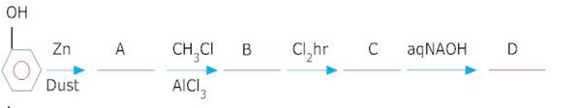
8.
9. Write structures of the products of the following reactions:
(i)
(ii)
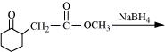
(iii)
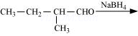
10. Write the equation of the reaction of hydrogen iodide with:
(i) 1-propoxypropane
(ii) Methoxybenzene and
(iii) Benzyl ethyl ether

Answers:
Write the equation of the reaction of hydrogen iodide with:
(i) 1-propoxypropane
(ii) Methoxybenzene and
(iii) Benzyl ethyl ether
Ans. (i)
(ii)
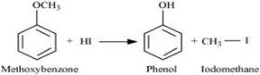
(iii)
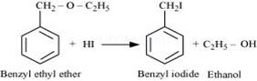
An organic compound ‘ A ‘ having molecular formula on treatment with aq. give ‘B’ which on treatment with Lucas reagent gives ‘C’. The compound ‘C’ on treatment with ethanolic KOH gives back ‘A’ .Identify A, B, C .
Ans.
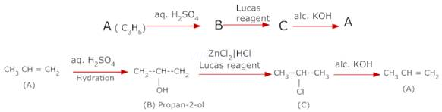
12. An organic compound gives a characteristic colour with aq. solution. (A) On reacting with and NaOH at 400k under pressure gives (B) which on acidification gives a compound (C) .The compound (C) reacts with acetyl chloride to give (D) which is a popular pain killer. Deduce the structure of A,B,C & D.
Ans.
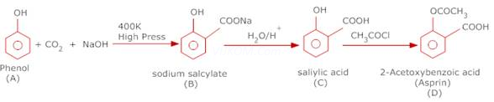
13. An organic compound (X) when dissolved in ether and treated with magnesium metal forms a compound Y. The compound, Y, on treatment with acetaldehyde and the product on acid hydrolysis gives isopropyl alcohol. Identify the compound X. What is the general name of the compounds of the type Y.
Ans. The compound X is and Y is The compounds of the type ‘Y’ are called Grignard reagent.
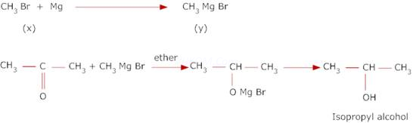
14. A compound ‘A’ with molecular formula C₄H₁₀O on oxidation forms compound ‘B’ gives positive iodoform test and on reaction with CH₃MgBr followed by hydrolysis gives (c). Identify A, B & C.
Ans. The compound ‘B’ is obtained by oxidation of and gives positive iodoform test and also reacts with , it must be methyl Ketone , it must be methyl ketone having four carbon atoms i.e, .
This can be obtained by oxidation of 2 – butanol i.e , 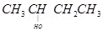Therefore , the reactions are.
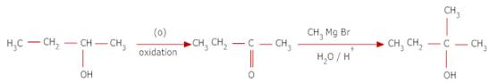
15. An aromatic compound (A) having molecular formula on treatment with CHCl₃ and KOH gives a mixture two isomers ‘B’ and ‘C’ both of ‘B’ & ‘C’ give same product ‘D’ when distilled with Zn dust. Oxidation of ‘D’ gives ‘E’ of formula. The sodium salt of ‘E’ on heating with soda lime gives ‘F’ which may also be obtained by distilling ‘A’ with zinc dust. Identify compounds ‘A’ to ‘F’ giving sequence of reactions.
Ans.
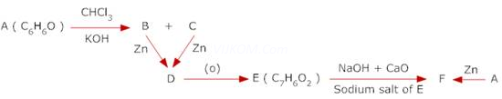The aromatic compound having molecular formula and which gives a mixture of two isomers on reacting with and KOH is phenol i.e.
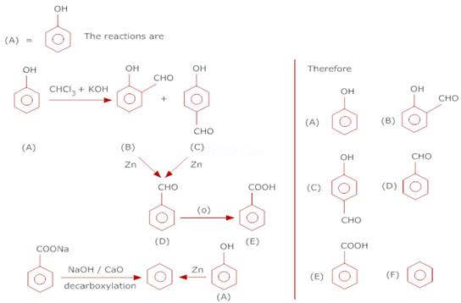
16. Compound ‘A’ of molecular formula gives a compound ‘B’ of molecular formula when treated with aq. NaOH. On oxidation the compound yields a mixture of acetic acid & propionic acid. Deduce the structure of A, B & C.
Ans.
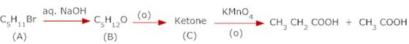
Since acetic acid & propionic acid are the products of oxidation of C which is a ketone, C is . Since it is the oxidation product of B, therefore
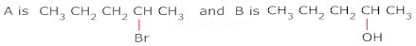
The reactions are
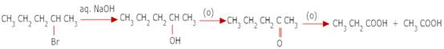
17.
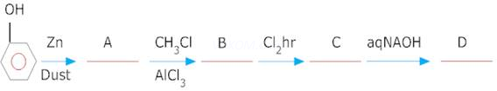
Ans.
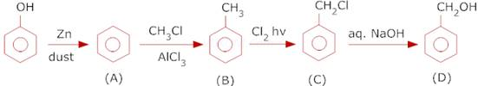
18.
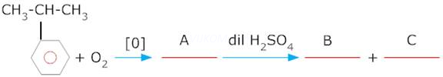
Ans.
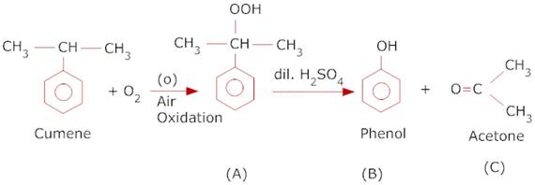
19. Write structures of the products of the following reactions:
(i)
(ii)
(iii)
Ans. (i)
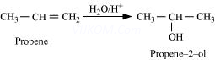
(ii)
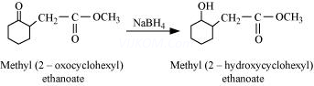
(iii)
